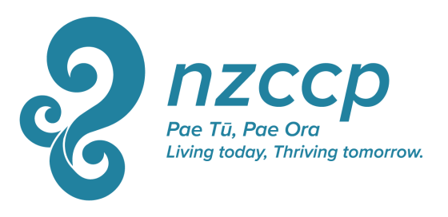

NZCCP Travel Grant

Description: Up to four NZCCP Travel Grants of up to $1,000 are provided annually to Full or Associate members of the College to assist to them travel to and attend a continuing education opportunity (such as a Conference, Workshop, or substantial organised site visit) either in New Zealand or overseas. The grant may be used to fund travel, accommodation, a daily allowance, and other expenses directly related to the above purpose and detailed in the application.

Criteria: Preference will be given to applicants who specify clear learning and or skill-development outcomes from the activity.
Applications will be assessed on the extent of the relevance of proposed learning to the applicant’s role as a Clinical Psychologist.

Feedback: A condition of accepting this Grant is that the member agrees to write a brief (typically up to 1,000 words) report on the continuing education activity and/or their major learnings from the activity. This synopsis may be published in an NZCCP publication such as ShrinkRAP or the Journal of the NZCCP. For more information download the guidelines for authors here.

Application Process: Calls for applications will be announced during December via e mail, in appropriate NZCCP publications such as ShrinkRAP, and by posting on the NZCCP website. Applications should be completed on the NZCCP Travel Grant form and submitted with any requested supporting documentation to the College Executive Director by the end of February of the following year.
The National Executive will select a minimum of two reviewers to review all proposals, and on the basis of feedback from these reviewers, the National Executive will select the successful recipient. The National Executive’s decision is final.
The successful recipient will be informed by the end of March.
Unsuccessful Applicants are not precluded from reapplying in the future.

Application Form: NZCCP Travel Grant

Name:
Address
Phone
Mobile
E mail

Please specify the title, date, and location of the activity you wish to attend. If the nature of the activity is unclear from the title, please briefly describe the nature of the learning opportunity (200 word maximum)

Are you providing content for the activity? (eg, presenting a paper or workshop)
YES NO If YES - please briefly describe the type of content you are providing.

What are your expected learning outcomes from the activity described above? (200 words maximum)

How will undertaking this activity change, extend, or otherwise contribute to your practice, research, understanding, or work in clinical psychology? (200 words maximum).

If you are the successful recipient of a NZCCP Travel Grant, do you agree to provide a brief report on the activity you undertook that was supported by this award, and what you learned from this activity? This report may be published in an NZCCP publication such as ShrinkRAP (cross out or delete one of following) YES NO

What expenses are you seeking this grant to cover? (Maximum total = $1,000)
Description of Expense | Amount
Total Requested

Notes:
- If you are applying for a course, workshop, training programme, or similar, please supply a copy of the brochure, registration material, or other similar information describing the contents.
- If you are travelling to study with or visit a particular practitioner, please provide a biography of that person and a description outlining the contribution they have made to the field. If possible, please also provide a letter from that person indicating their agreement for you to study/visit with them.
- Any air fares purchased with this grant must be an economy fare. With travel and other expenses, please quote for and endeavour to obtain goods and services that are as inexpensive as reasonable while meeting your reasonable needs.
- Cost over-runs from the quoted budget will be met only at the discretion of the NZCCP. The total budget amount of $1,000 will not be exceeded.

