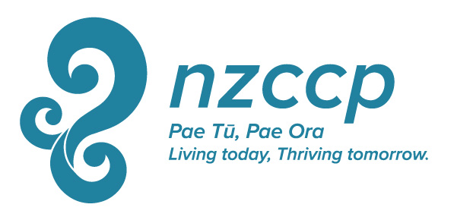
NZCCP Full Membership Renewal
1 July 2017 – 30 June 2018

Annual Full Membership Fee is $350
First names
Family Name |  |  |  | Title: Dr/Ms/Mrs/Miss/Mr
Mailing address

Telephone | Mobile/  Home Phone |  |  |  |  | Fax
Email

Date of Birth / / |  | Gender: M/F | Ethnic Origin
If you are of Maori descent, please supply details of your
Iwi: |  |  |  |  | Rohe (Iwi Area):
What languages, other than English, do you use professionally with clients?

Please indicate how many FTEs you work and for which employer:
FTE |  | FTE |  |  | FTE
 | ACC |  | Iwi Health Provider |  |  | Pro-bono/volunteer
 | Child, Youth & Family |  | NGO |  |  | University
 | Dept of Corrections |  | PHO |  |  | Other (please specify)
 | District Health Board |  | Private practice
What are your area(s) of interest/specialty?

I hereby renew my Full Membership with the NZ College of Clinical Psychologists
I also make the following declarations:
I am a New Zealand Registered Psychologist (Clinical Scope of Practice). |  |  |  |  |  |  |  | True/False
In the past 12 months I have not been the subject of any complaint to the Health and Disabilities Commissioner, the New Zealand Psychologists Board or an equivalent overseas body. |  |  |  |  |  |  |  | True/False
If there is such a complaint I agree to provide details of the complaint to the True/False
President of the NZCCP and authorise the agency to whom the complaint was
made to release all records and information pertaining to the complaint to the
President of the NZCCP.
The above Information is true and accurate
Signed |  |  |  | Date
MPS Subscription Renewal
I declare that:
- I agree to be bound by the Memorandum of Articles and Association currently in force with MPS
- I understand that if my subscription is in arrears for more than one month then I shall cease to be entitled to any membership benefits from MPS from the date when such subscription fell due.
- I also understand that after non-payment of three months then MPS may terminate my membership by notice.
Signed Date

Supervision Contract

between NZCCP member and supervisor

1 July 2017 – 30 June 2018

Name of Member: Phone:

Name of Supervisor: Phone:

Profession of Supervisor:

Conduct of Supervision:
- All members of NZCCP shall have supervision of their clinical work.
- Members are responsible for determining the nature and frequency of the supervision they receive. However, as a guideline, one hour supervision every two weeks for a clinician in full time work is considered adequate. Peer supervision and group supervision are acceptable.
- The working format for supervision sessions shall be defined by the Supervisor and Member at the outset of supervision, taking into account the needs and priorities of the Member, and the skills and resources of the Supervisor. The inclusion of some direct observation (audio tape, video, screen etc.) is strongly encouraged.
- Supervision shall be with any qualified person a member considers to be appropriate in order to meet their supervision needs (e.g. psychologist, psychotherapist, psychiatrist or counsellor).
- The Supervisor and Member shall work out the goals and objectives of the supervision process.
- The goals and objectives for the next 12 months shall be:

- Any other specific terms of contract:

We hereby undertake to meet at ……………intervals for ……. hours per meeting for the next 12 months starting on.……/……./……….

Signed

Member Supervisor

Supervision is a requirement of NZCCP membership
Please return this form to the address below

