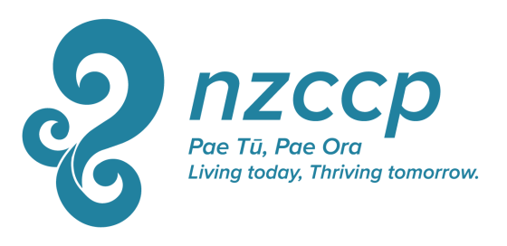

NZCCP President’s Award

Description: This award of up to $1,500 is offered annually to a student member of the College who is recognised as performing well in their training and as likely to make a positive contribution to Clinical Psychology in the future. The purpose of this award is to assist the student member to undertake the development of their knowledge and skills in Clinical Psychology and its application. The grant may be used to fund travel, accommodation, a daily allowance, or other expenses directly related to the above purpose, as detailed in their application.

Criteria: This award is open to student members of the College who will not be receiving a full-time or substantially full-time salary (e.g. a paid internship) during the period from the time of announcement (in December) until July of the following year.
Preference will be given to applicants who specify clear learning and or skill-development outcomes from the activity (e.g., developing a specific new skill set rather than merely attending a conference). Other criteria on which applications will be assessed include.
- Relevance of proposed learning to the applicant’s development as a future clinical psychologist
- The student member is recognised as performing at a satisfactory or higher level in the academic and practicum components of their training. Consultation with one or more referees will be required to ensure this.

Feedback: A condition of accepting this Award is that the student member agrees to write a brief (typically up to 1,000 words) synopsis of the learning activity and/or their major learnings from the activity. This synopsis may be published in an NZCCP publication such as ShrinkRAP or the Journal of the NZCCP. For more information download the guidelines for authors here.

Application Process: Calls for applications will be announced during December via e mail, in appropriate NZCCP publications such as ShrinkRAP, and by posting on the NZCCP website. Applications should be completed on the study grant form and submitted with requested supporting documentation to the College Executive Director by the end of February of the following year.
The National Executive will select a minimum of two reviewers to review all proposals, and on the basis of feedback from these reviewers, the National Executive will select the successful recipient. The National Executive’s decision is final.
The successful recipient will be informed by the end of March.
Unsuccessful applicants are not precluded from reapplying in the future.

Application Form: NZCCP President’s Award

Name:
Address
Phone
Mobile
E mail
Clinical Psychology Programme Engaged in:

Describe what you wish to use the NZCCP President’s Award to do? (200 word maximum)

What are your expected learning outcomes from the activity described above? (200 words maximum)

How will undertaking this activity assist your development towards becoming a clinical psychologist? (200 words maximum).

If you are the successful recipient of the NZCCP President’s Award, do you agree to provide a brief report on the activity you undertook that was supported by this award and what you learned from this activity. This report may be published in an NZCCP publication such as ShrinkRAP (cross out or delete one) YES NO

What expenses are you seeking this grant to cover? (Maximum total = $1,500)
Description of Expense | Amount
Total Requested

Please provide the name and contact details of two referees who would be able to comment on your performance within your clinical psychology programme. Referees may include academic staff and clinical supervisors.

Name
Address
Telephone Number

Name
Address
Telephone Number
Notes: NZCCP President’s Award

- If you are applying for a course, workshop, training programme, or similar, please supply a copy of the brochure, registration material, or other similar information describing the contents.
- If you are travelling to study with or visit a particular practitioner, please provide a biography of that person and a description outlining the contribution they have made to the field. If possible, please also provide a letter from that person indicating their agreement for you to study/visit with them.
- Any air fares purchased with this grant must be an economy fare. With travel and other expenses, please quote for and endeavour to obtain goods and services that are as inexpensive as reasonable while meeting your reasonable needs.
- Cost over-runs from the quoted budget will be met only at the discretion of the NZCCP. The total budget amount of $1,500 will not be exceeded.

